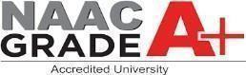
Official Project Report
on

Real Estate Mobile App (Rentconnect)

Submitted to:

University Institute of Computing

Submitted by:

PRINCE W DAHN JR(24MCC20097)



Chandigarh University, Mohali

April 17, 2026
BONAFIDE CERTIFICATE

Certified that this project report “ Real Estate Mobile App (Rentconnect)” is the Bonafide work Of “PRINCE W DAHN JR” who carried out the project work under my/our supervision.

SIGNATURE SIGNATURE

Dr. Krishan Tuli
HEAD OF THE DEPARTMENT
(University Institute of Computing)

Submitted for the project viva-voce examination held on

INTERNAL EXAMINER EXTERNAL EXAMINER

Table Of Content
CHAPTER1: INTRODUCTION… 1-9

  - Need Identification

  - Identification of problem

  - Identification of tasks

  - Timeline

  - Organization of the report CHAPTER 2: BACKGROUND
STUDY……………………………………………………….10-23 2.1. Timeline of the reported problem
  - Proposed Solution

  - Bibliometric analysis
  - Review Summary

  - Problem Definition

  - goals/ Objective

  - Why Use Technologies Over Other

CHAPTER 3: DESIGN AND PROCESS… 24-54
  - Evaluation & Selection of Specifications/Features

  - Design Constraints

  - Design Flow

  - Creation of “Rentconnect”

  - Logo Designing and Naming

  - Implementation plan/methodology
CHAPTER 4: RESULT ANALYSIS AND VALIDATION 55-61
  - Implementation of solution

    - Report preparation,

    - Project management, and communication
    - Testing/characterization/interpretation/data validation.
CHAPTER 5: CONCLUSION AND FUTURE WORK… 62-66
  - Conclusion

  - Future Work

Plagiarism report…………………………………………………………………………….

ABSTRACT
This project presents the design and development of RentConnect, a mobile-based real estate application built using Flutter. The system aims to provide a modern, user-friendly platform that connects property owners, agents, and tenants, simplifying the process of listing, searching, and managing rental properties.
The frontend of the application is developed using Flutter, enabling a cross-platform mobile experience with a responsive and visually appealing interface. The backend is powered by cloud-based services such as Firebase and Supabase, which handle authentication, real-time database management, and secure data storage. This architecture ensures scalability, high performance, and seamless synchronization of user data.
RentConnect allows property owners to upload and manage listings, while tenants can browse available properties, apply filters, and send booking requests in real time. Key features include user authentication, dynamic property listings, real-time updates, and integrated communication tools, all designed to enhance user interaction and efficiency.
The application is version-controlled using GitHub and follows modern development practices to ensure maintainability and continuous improvement. By leveraging mobile technology and cloud infrastructure, RentConnect provides a reliable and accessible solution to challenges in the rental market.
In conclusion, the project demonstrates the effective use of Flutter and cloud backend technologies to build a scalable and user-centric rental platform. It lays the foundation for future enhancements such as payment gateway integration, push notifications, and advanced recommendation systems.

LIST OF FIGURES
Fig 1… 0
Fig 2… 32
Fig 3… 34
Fig 4… 34
Fig 5… 35
Fig 6… 36
Fig 7… 38
Fig 8… 39
Fig 9… 40
Fig 10… 42
Fig 11… 42
Fig 12… 45
Fig 13… 46
Fig 14… 46
Fig 15… 47
Fig 16… 47
Fig 17… 48
Fig 18… 53
Fig 19… 53
Fig 20… 54

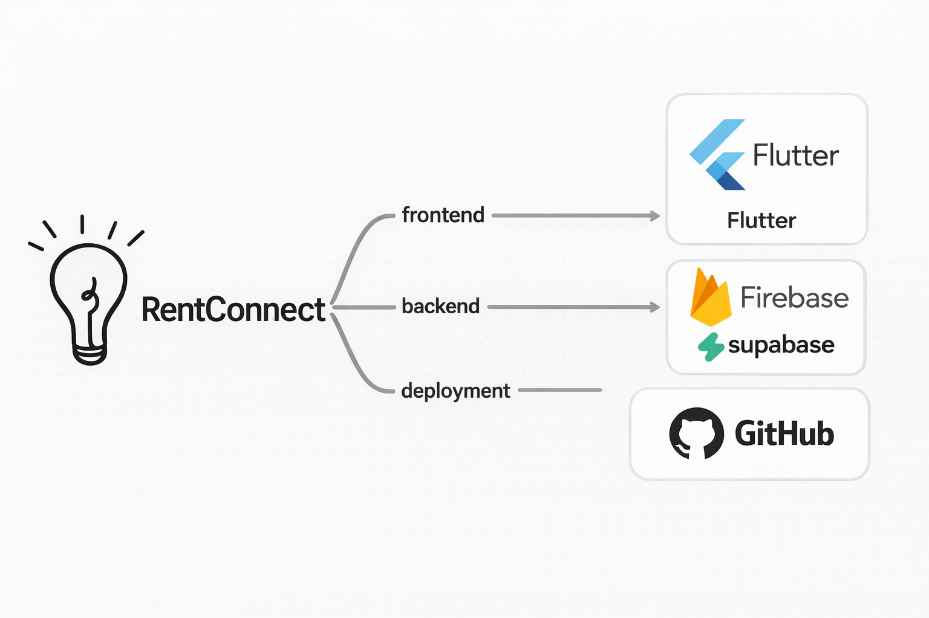
Fig 1
CHAPTER 1 INTRODUCTION

Need Identification
In the modern era, technology has become an essential part of daily life, transforming how people communicate, work, and even find places to live. The real estate industry, like many others, has experienced a major shift from traditional methods toward digital platforms that simplify processes and enhance user convenience. However, despite these advancements, many property owners, agents, and tenants in developing and even advanced regions continue to face difficulties in effectively connecting with one another. These challenges create a growing need for an efficient, accessible, and user-friendly online platform that bridges the gap between landlords and property seekers.
RentConnect was conceptualized and developed to meet this specific need — to create a single, centralized platform that simplifies the process of renting and managing properties. The idea behind RentConnect originated from observing the real-world difficulties faced by both tenants and landlords.
For example, tenants often spend considerable time searching for available houses, making multiple phone calls, or traveling long distances to verify listings that may already be taken. On the other hand, property owners struggle to reach potential tenants quickly or manage multiple property listings at once. Many of these challenges are due to the lack of transparency, poor communication, and inefficient manual processes that dominate the traditional real estate market.
With RentConnect, these issues are addressed through a digital solution that provides convenience, accuracy, and accessibility. The platform allows property owners to easily list their properties, add detailed information such as location, rent amount, and amenities, and manage their listings without needing any technical expertise. Meanwhile, tenants can search for available properties based on their preferences, apply filters such as price range or property type, and even contact the owners directly through the platform. This not only saves time but also minimizes the need for middlemen, reduces the chances of fraud, and creates a more transparent rental environment.
The growing reliance on the internet and mobile devices further emphasizes the need for such a platform. Today, most users prefer to access services online rather than visit physical offices. RentConnect takes advantage of this digital trend by offering an interactive and responsive web experience that can be accessed from any device, anywhere. This makes it especially useful for working professionals, students, and families who are looking for rental properties but have limited time to engage in long, manual search processes.
Another important reason behind the development of RentConnect is the inefficiency of existing systems in managing rental data. Many property owners still rely on handwritten records or basic spreadsheets to track tenants, payments, and property status. This approach often leads to data loss, errors, and poor record-keeping. By contrast, RentConnect provides a structured database-driven solution where all property and user information is securely stored and easily retrievable. This not only improves accuracy but also enhances decision-making for both owners and renters.
From a broader perspective, the need for a digital property management system also aligns with the growing demand for transparency and security in online transactions. Users today expect systems that protect their data, ensure privacy, and provide reliable information. RentConnect was built with these expectations in mind, integrating secure login systems, data validation mechanisms, and user authentication to prevent unauthorized access.
Moreover, RentConnect supports scalability — meaning that as more users, properties, and features are added, the platform can continue to perform efficiently. This makes it a sustainable long-term solution for the modern real estate industry. In addition to its technical benefits, RentConnect also contributes socially by promoting trust between property owners and tenants, encouraging fair pricing, and
providing a more structured approach to renting.

In conclusion, the identification of the need for RentConnect emerged from a clear observation of the inefficiencies in the current real estate system and the growing potential of digital transformation. The platform aims to make property management and rental processes easier, faster, and more reliable. By leveraging web technologies and a user-centric design, RentConnect not only addresses the pressing challenges faced by landlords and tenants but also sets the foundation for a smarter, more connected, and transparent real estate experience.

Identification of Problem
The process of finding, renting, and managing properties has traditionally been stressful, time-consuming, and often inefficient. Even with the rise of digital technologies, many people still depend on outdated methods such as word of mouth, local agents, or physically visiting multiple locations to find suitable rental properties. These traditional approaches create unnecessary delays, increase costs, and make the overall experience frustrating for both tenants and property owners. This situation clearly shows the need for a modern solution that can simplify and improve the rental process.
One of the biggest challenges in the current system is the lack of accessibility and convenience. Many potential tenants struggle to find accurate and up-to-date information about available properties. In most cases, listings are scattered across different platforms or shared informally, making it difficult to compare options efficiently. On the other hand, property owners face challenges in reaching a wider audience, especially beyond their immediate location. Without a centralized platform that works seamlessly on both mobile devices and web browsers, users are limited in how they access and interact with rental information.
Another major issue is the lack of transparency and trust between tenants and landlords. In traditional rental systems, there is often no proper verification of property listings or user identities. This creates opportunities for fraudulent activities, such as fake listings, misleading property descriptions, or incorrect pricing information. Tenants may end up wasting time and money visiting properties that do not meet their expectations, while landlords may encounter unreliable tenants. The absence of a secure and trustworthy system discourages users from fully relying on digital rental platforms.
Data management is also a significant problem in the existing system. Many property owners still rely on manual methods, such as notebooks or basic spreadsheets, to keep track of tenant details, rent payments, and property records. These methods are not only inefficient but also prone to errors, data loss, and inconsistencies. Tenants, on the other hand, often lack a structured way to store or access their rental history and agreements. Without a centralized and digital database, it becomes difficult to manage, update, and retrieve important information when needed.
Communication barriers further complicate the rental process. In many cases, there is no direct or structured way for tenants and property owners to interact. This leads to delays in responding to inquiries, missed opportunities, and misunderstandings. For example, a tenant may not receive timely feedback about a property, or a landlord may miss potential clients due to poor communication channels. Efficient and real-time communication is essential for improving user experience and ensuring smooth transactions.
In addition, many existing digital solutions do not provide a consistent cross-platform experience. Some platforms are designed only for web use, while others focus solely on mobile applications. This lack of integration creates inconsistencies in user experience and data synchronization. Users expect to access the same information whether they are using a smartphone or a computer. Without proper synchronization, data may become outdated or inconsistent across platforms, reducing the reliability of the system.
Scalability and affordability are also important concerns. Many real estate platforms available today are expensive or overly complex, making them unsuitable for small-scale property owners or individual users. These platforms often require subscription fees or technical expertise, which limits their adoption. There is a clear need for a simple, cost-effective solution that can be used by a wide range of users without requiring advanced technical knowledge.
Security and privacy issues cannot be overlooked. As more users move towards online platforms, they expect their personal information, login credentials, and property data to be secure. However, many existing systems lack strong security measures, making them vulnerable to data breaches and unauthorized access. This creates a risk for users and reduces their confidence in digital platforms.
To address these challenges, there is a strong need for a unified system that combines the strengths of both mobile and web technologies. The RentConnect project is designed to meet this need by providing an integrated platform built with Flutter for mobile access and supported by a robust web-based system. It aims to offer a secure, user-friendly, and efficient environment where property owners can list and manage their properties, while tenants can easily search, filter, and communicate in real time.
By solving the problems of accessibility, transparency, data management, communication, and security, RentConnect provides a modern approach to property rental. It not only improves user experience but also creates a more reliable and trustworthy system for all stakeholders involved.

Identification of Tasks
After clearly identifying the major challenges in the traditional property rental system, the next step was to define the key tasks required to build an effective and modern solution. The goal of the RentConnect project is not only to develop a system but to ensure that it solves real-world problems such as lack of accessibility, poor communication, low transparency, and weak security. To achieve this, the development process was divided into well-structured tasks, following a systematic approach aligned with modern software development practices.
The first and most important task was requirement gathering and analysis. Before starting development, it was necessary to understand the needs of different users, including property owners, agents, and tenants. This involved analyzing how users currently interact with rental systems, identifying their pain points, and determining what features would improve their experience. Based on this analysis, the core functionalities of RentConnect were defined. These include user registration and login, property listing and management, property search and filtering, booking requests, and communication between users. This phase provided a clear foundation for both the mobile and web versions of the system.
The second task was system architecture and database design. Since RentConnect is built as both a Flutter mobile application and a web platform, it required a scalable and well-organized architecture. The system was designed to separate the frontend, backend services, and database layers. Supabase was selected as the primary database solution due to its real-time capabilities and cloud-based structure. It allows efficient storage and management of user data, property listings, and booking records. Tables and relationships were carefully designed to ensure data consistency, fast retrieval, and scalability. Additionally, Firebase Authentication was integrated to provide secure user login and identity management across both platforms.
The third task involved frontend development for both mobile and web platforms. The mobile application was developed using Flutter, which enables cross-platform compatibility and a smooth, responsive user interface. Flutter allows the app to run efficiently on Android devices while maintaining a modern and user-friendly design. At the same time, the web platform was developed to ensure accessibility through browsers, allowing users who prefer desktops or laptops to interact with the system. Both interfaces were designed with simplicity and usability in mind, ensuring that users can easily navigate, search for properties, and perform actions without technical difficulty.
The fourth task was backend integration and functionality implementation. This step focused on connecting the frontend interfaces (Flutter app and web platform) with backend services such as Supabase and Firebase. Supabase was used to handle real-time database operations, including storing and retrieving property data, user profiles, and booking information. Firebase Authentication was implemented to manage secure user login, registration, and session handling. Additional functionalities such as property CRUD (Create, Read, Update, Delete), search filters, and booking requests were developed to ensure a complete and interactive system.
Another important task was system integration. This involved ensuring that all components — mobile app, web platform, database, and authentication system — work together seamlessly. Data synchronization between Flutter and the web platform was carefully implemented so that any updates made on one platform are reflected instantly on the other. This ensures consistency and improves user experience across devices.
Testing and debugging formed the next critical task. The system underwent multiple testing phases, including unit testing, integration testing, and user testing. These tests were conducted to verify that all features function correctly, data is handled properly, and the system performs well under different conditions. Bugs and errors identified during testing were resolved to improve reliability, security, and performance.
Following testing, deployment was carried out. The web platform was deployed using a reliable hosting service, while the Flutter application was prepared for mobile deployment. Version control was maintained using GitHub, allowing efficient tracking of changes and collaboration. Basic DevOps practices were applied to ensure smooth updates and continuous improvement of the system.
Finally, documentation was completed to describe the entire development process. This includes system architecture, database design, features, and user guidelines. Proper documentation ensures that the system can be easily maintained, updated, and understood by future developers or users.
In conclusion, the identification of tasks for the RentConnect project followed a structured and logical approach, ensuring that every aspect of development was carefully planned and executed. By combining Flutter, Supabase, Firebase Authentication, and web technologies, the project successfully delivers a scalable, secure, and user-friendly rental platform that addresses real-world challenges in the property market.

Timeline

Effective project execution requires careful planning and time management. The development of RentConnect was organized into a structured timeline to ensure that each phase of the project was completed systematically, efficiently, and within the set duration. The timeline not only helped maintain focus but also ensured that every milestone was achieved on schedule without compromising quality.
This time-based approach followed the principles of the Software Development Life Cycle (SDLC), which emphasizes step-by-step progress from requirement analysis to deployment and documentation.
The project was planned over eight weeks, with each week dedicated to specific deliverables and milestones. The distribution of tasks was carefully designed to balance both technical and analytical aspects of development. The timeline also included review sessions, testing, and refinements to
guarantee a polished and stable final product.

Phase | Dura tion | Activities | Deliverables / Outcomes
Week 1:  Requirement Analysis | 7  Days | Conducted requirement gathering sessions, identified user needs, and defined  system scope. | Detailed requirement document and list of core features for  RentConnect.

Week 2: System Design | 7  Days | Created architecture diagrams, ER models, and database schema; designed system flow and interface mockups. | Completed design documentation including database schema and system flowchart.
Week 3:  Frontend Development | 7  Days | Developed the web interface using HTML, CSS, and Bootstrap. Created  responsive layouts and integrated UI elements. | Functional user  interface prototype ready for integration.
Week 4: Backend Development | 7  Days | Implemented backend logic using PHP; set up CRUD operations, authentication system, and database connectivity. | Fully functional backend with secure user authentication and data management.
Week 5: Integration | 7  Days | Integrated frontend and backend components; connected forms and pages to the database. | Working web application with linked modules.
Week 6: Testing and Debugging | 7  Days | Conducted unit, integration, and user acceptance testing; fixed bugs and optimized performance. | Stable version of RentConnect with verified functionality.
Week 7: Deployment | 7  Days | Deployed the project using Hostinger; configured domain, SSL, and environment settings. | Live RentConnect platform accessible online.
Week 8: Documentation and Review | 7  Days | Prepared technical documentation, user manual, and project report; conducted  final evaluation. | Completed project documentation and presentation-ready  report.
Each phase of the timeline was interconnected, meaning that the success of one stage depended heavily on the completion of the previous stage. This structured sequence ensured that no phase was rushed or overlooked. Below is a detailed explanation of how these weeks contributed to the overall success of the project.
During Week 1, the primary focus was to understand the real-world challenges faced by property
owners and tenants. This involved identifying functional and non-functional requirements and defining the overall scope of RentConnect. The deliverable from this phase was a well-structured requirement document that acted as a blueprint for the next steps.
In Week 2, the project transitioned to design. This was one of the most crucial phases, as it involved creating visual wireframes and logical data structures. The system design phase defined the three-tier architecture of the platform — frontend (HTML, CSS, Bootstrap), backend (PHP), and database (MySQL). Proper planning at this stage reduced complexities during development.
Week 3 focused on frontend development, where visual and interactive components were built. The goal
was to ensure an attractive, user-friendly interface that worked seamlessly on both desktop and mobile devices. During Week 4, backend development began, integrating logical functionalities, authentication, and data handling. Security and efficiency were key priorities at this stage.
Week 5 was dedicated to integration, connecting all modules and ensuring smooth communication between the client-side interface and the server-side logic. Once the integration was successful, Week 6 focused on testing and debugging. This stage ensured that the system was free from critical errors and met user expectations. Multiple testing techniques, such as unit testing and user acceptance testing, were applied.
In Week 7, the focus shifted to deployment using Hostinger. The platform was uploaded to a live environment, configured for performance, and tested for accessibility from different devices. This made RentConnect publicly available and ready for user interaction.
Finally, Week 8 concentrated on documentation and review. A detailed project report, user guide, and
maintenance plan were prepared. The entire project was evaluated against the initial objectives to ensure that all requirements were met successfully.
Overall, the timeline played a vital role in keeping the project organized and efficient. By allocating sufficient time for planning, execution, testing, and documentation, the RentConnect project was completed smoothly within the planned schedule. The structured timeline not only ensured timely delivery but also allowed flexibility for modifications and quality improvements. This disciplined approach reflects the importance of time management in real-world software development and
demonstrates how effective scheduling contributes to the success of a project.

1.5 Organization of the Report
A well-structured report is essential for presenting a project in a logical, organized, and reader-friendly manner. The RentConnect project report has been systematically arranged to ensure that each stage of development, from concept to implementation, is clearly explained and easy to follow. The purpose of this organization is to help readers — including instructors, examiners, and fellow students —
understand the motivation behind the project, the methodologies used, the technologies applied, and the outcomes achieved.
The report is divided into several chapters, each focusing on a specific part of the project’s development life cycle. This structured organization reflects the systematic approach adopted during the execution of RentConnect and ensures a smooth flow of information from problem identification to conclusion.
Below is a detailed explanation of how each section contributes to the overall report.
The first chapter, Introduction, provides a general overview of the project. It discusses the background and motivation behind developing a real estate platform like RentConnect, along with its main objectives, scope, and the problems it seeks to address. This chapter sets the foundation for the report by describing the significance of the project in today’s real estate environment and highlighting the gaps in existing systems. It also introduces key terms and explains the relevance of modern web technologies in solving the identified issues.
The second chapter, Tools and Technologies Used, outlines all the software tools, programming languages, frameworks, and platforms utilized during the development process. This includes front-end technologies such as HTML, CSS, and Bootstrap; backend technologies such as PHP and MySQL; and
deployment tools like Hostinger and GitHub. Each tool is described in terms of its role in the system and why it was chosen over alternative technologies. This chapter serves to demonstrate the developer’s understanding of selecting appropriate tools to meet project requirements effectively.
The third chapter, Implementation Steps, provides a detailed, step-by-step explanation of how the system was developed. This section follows a chronological order that mirrors the project’s actual
workflow — starting with requirement analysis, followed by design, development, integration, testing, and deployment. Each step explains the methodologies applied, challenges faced, and solutions implemented to ensure a functional and reliable end product. The chapter highlights how theoretical
knowledge gained during coursework was applied in practical, real-world development scenarios.
The fourth chapter, Result and Analysis, presents the outcomes of the project. It describes how the RentConnect platform performs, analyzes the functionality of key features such as property listing, search, and user authentication, and discusses the efficiency of the database design and backend logic. This chapter also includes user feedback, system performance evaluation, and limitations identified during testing. The analysis demonstrates the effectiveness of the implemented solution and assesses how well it meets the original project goals.
The fifth chapter, Conclusion, summarizes the entire project and provides reflections on the learning outcomes. It highlights the knowledge and skills acquired during the development of RentConnect and evaluates the project’s contribution to solving real-world problems in the real estate domain. The conclusion also outlines potential future enhancements such as integrating a payment gateway, developing a mobile application, or implementing real-time chat features. This section helps the reader understand how the project can evolve beyond its current version.
Finally, the References section lists all the sources consulted throughout the research and development process. This includes books, academic articles, online tutorials, and documentation that guided the technical and theoretical aspects of the project. Proper citation ensures academic integrity and
acknowledges the contributions of other authors whose work supported the project’s completion.
In addition to these main chapters, the report includes front matter such as the Certificate, Acknowledgment, and Abstract. The Certificate authenticates that the project was completed under proper supervision, the Acknowledgment expresses gratitude to individuals and institutions that provided support, and the Abstract offers a concise summary of the project’s purpose, methods, and outcomes.
Overall, the report’s organization follows a logical flow that mirrors the actual process of software development — from conceptualization and planning to design, implementation, and evaluation. This structure not only enhances readability but also ensures that the reader can easily trace the evolution of the project and understand how each component contributes to the final product.
The clarity and order of presentation make it possible for anyone reading the report to grasp both the technical and conceptual aspects of RentConnect. It reflects the disciplined approach taken by the developer in completing the project and serves as a professional document that demonstrates technical competence, analytical ability, and communication skills — all of which are essential qualities for a modern software engineer or IT professional

9

CHAPTER 2 BACKGROUND STUDY

Timeline of the Reported Problem

Over the past decade, the real estate sector has undergone gradual transformation through digital technologies, yet challenges in renting and property management have persisted. Traditionally, the process of renting a property involved physical visits, newspaper advertisements, and third-party brokers. While these methods served their purpose in the past, they often led to inefficiency, misinformation, and additional financial costs for both landlords and tenants.
The timeline of the reported problem traces back to the increasing urbanization in the early 2000s, when demand for rental housing surged globally. As cities expanded, finding rental properties became more competitive and complex. Despite the availability of internet platforms, many users in developing regions such as Liberia and other African countries continued to rely on manual methods. Between 2010 and 2020, online property listing websites began emerging, but they lacked regional focus, personalization, and security.
The COVID-19 pandemic further exposed these gaps, as physical visits and paper-based agreements became impractical. The need for reliable online platforms became urgent — systems that not only list properties but also manage communication, authentication, and trust between users. This is where RentConnect finds its relevance: as a response to a long-standing problem that intensified over time and now demands a secure, automated, and user-friendly online solution.

Proposed Solution

The proposed solution, RentConnect, is a modern web-based real estate platform designed to simplify and digitize property rental management. It aims to connect landlords, agents, and tenants under one digital ecosystem that allows seamless property listing, searching, booking, and communication.
Through the integration of technologies like HTML, CSS, Bootstrap, PHP, and MySQL, RentConnect delivers a user-friendly and efficient experience. It allows landlords to upload property information,
tenants to filter and search listings based on preferences, and agents to manage communications effectively.
The system also incorporates essential features such as secure authentication, password protection, and data validation to ensure user privacy and system reliability. By deploying the platform through Hostinger, it achieves high availability, scalability, and cost-effectiveness — key requirements for a professional online system.
Unlike traditional real estate models, RentConnect eliminates dependency on brokers, reduces communication delays, and introduces automation through a centralized digital system. This solution not only streamlines the property rental process but also builds trust, reduces human error, and promotes transparency within the real estate ecosystem.

Bibliometric Analysis

A bibliometric analysis helps understand the scholarly trends and research directions related to digital real estate systems and online rental management. Studies published between 2015 and 2024 reveal an increasing focus on digital transformation within the housing and property sector.
For example, research by Welling and Thomson (2017) in PHP and MySQL Web Development emphasized the importance of database-driven web solutions in managing dynamic online systems. Similarly, Flanagan (2020) highlighted the need for interactivity and scalability in web applications through JavaScript-based functionality.
Recent publications in IEEE and Springer journals (2019–2023) have explored topics such as cloud computing for property management, automation through DevOps, and the importance of security in online user transactions. This growing body of literature supports the notion that integrating web and cloud technologies is not only beneficial but essential for modern real estate systems.
The bibliometric trend confirms that web-based platforms like RentConnect are part of a broader movement toward digitalization in service delivery — aligning academic research with practical innovation.

Review Summary

From the reviewed studies and observed trends, several insights were drawn. First, most existing platforms focus primarily on property listing rather than complete lifecycle management. Few offer
built-in communication tools, secure authentication, or database-driven automation.

Second, high costs and lack of localization make many commercial real estate solutions inaccessible in developing countries. Third, the combination of simple front-end tools (HTML, CSS, Bootstrap) with server-side technologies (PHP, MySQL) remains one of the most effective methods for building scalable, cost-efficient systems.
Finally, the integration of DevOps and CI/CD workflows, as seen in current academic and industrial research, demonstrates that automation is critical for sustainable system maintenance and deployment — a principle also applied in RentConnect.

Problem Definition

The core problem addressed by RentConnect is the absence of a unified, secure, and transparent online platform for managing rental properties efficiently. Existing methods are often fragmented, relying on multiple third-party agents or manual record-keeping, which leads to inefficiency, data loss, and limited accessibility.
There is a clear need for a centralized web solution that allows users to list, search, and manage rental properties while ensuring data integrity, ease of use, and security. RentConnect seeks to eliminate these barriers by offering a complete, integrated digital platform that connects all stakeholders in real time.

Goals / Objectives

The RentConnect project was developed with the following major objectives:

- To design and develop a responsive and dynamic real estate website.

- To enable landlords, tenants, and agents to interact in a centralized system.

- To simplify property listing, searching, and booking processes.

- To ensure security through authentication and encrypted password storage.

- To integrate automation in deployment and maintenance using DevOps tools.

- To host the system on a reliable web server for public accessibility.

- To enhance user convenience, transparency, and trust in the rental process.
These objectives collectively aim to create a complete digital experience for the real estate industry — one that saves time, improves accuracy, and fosters a transparent relationship among users.

Why Use These Technologies Over Others

The choice of technologies for RentConnect was guided by a balance between functionality, cost-efficiency, scalability, and ease of deployment.
    - HTML, CSS, and Bootstrap were chosen for the frontend because they are lightweight, widely supported, and ensure responsive design.

    - PHP was selected as the backend language due to its robustness, flexibility, and seamless integration with MySQL databases.

    - MySQL was used as the database system because of its reliability, open-source nature, and capability to handle relational data efficiently.

    - Hostinger was chosen for deployment as it offers a secure, affordable, and
performance-optimized hosting environment ideal for student and small business projects.

While newer technologies such as Node.js or Django could also be considered, PHP and MySQL provide a simpler, more accessible approach for small-scale, practical projects without compromising scalability or performance. These tools are widely supported, easy to maintain, and well-suited for web applications like RentConnect, ensuring that the final solution remains reliable, affordable, and easy to expand in the future

23
CHAPTER 3 DESIGN AND PROCESS

Evaluation and Selection of Specifications/Features

The success of any software project largely depends on how well its specifications and features align with user expectations, business objectives, and system performance goals. For RentConnect, the evaluation and selection of specifications were guided by three fundamental principles — usability, functionality, and scalability. These principles ensured that each feature implemented not only fulfilled a technical purpose but also contributed to a seamless and engaging user experience.
The design process began with a comprehensive analysis of existing real estate web platforms and detailed observations of user behavior and needs. Through this study, several recurring issues in traditional systems were identified — such as slow response times, limited search functionality, non-responsive design, and inadequate data security. In addition, the lack of integrated
communication channels and inefficient property management tools made it difficult for users to interact effectively. These insights helped shape RentConnect’s overall development strategy, ensuring that the platform directly addressed the shortcomings of similar systems.
Based on the evaluation results and feasibility analysis, the following key specifications were selected and implemented in RentConnect:

User Registration and Authentication

A secure user registration and login system was prioritized as the foundation for all user interactions. It enables landlords, agents, and tenants to create personal accounts and manage their activities within a protected environment. The authentication process was developed using PHP sessions and password encryption techniques to safeguard sensitive information. Data validation and error-handling
mechanisms were incorporated to prevent unauthorized access and improve overall security.

Property Listing and Management

For property owners and agents, the property listing module was designed to simplify the process of adding, editing, and deleting listings. Each property record includes essential details such as images, address, rent amount, property type, and description. These entries are stored securely in the MySQL database, ensuring that property data remains organized and easily retrievable. The design of this
feature emphasizes ease of use, allowing users with minimal technical knowledge to manage listings
without difficulty.

Search and Filter Functionality

To enhance user experience, a search and filtering mechanism was implemented, allowing tenants to find suitable properties based on specific criteria such as location, price range, and property type.
This functionality was achieved using PHP and SQL queries that dynamically fetch data from the database. It ensures quick access to relevant listings and reduces the time spent browsing unrelated options.

Contact and Booking System

A dedicated contact and booking feature enables direct communication between tenants and property owners. Users can send inquiries through a web-based form, and the submitted data is both stored in the database and emailed to the respective property owner for quick response. This feature promotes transparency and facilitates smoother interactions between both parties.

Responsive Web Design

Considering the diverse range of devices used by modern internet users, responsiveness was a critical design requirement. The front end was developed using HTML, CSS, and Bootstrap to ensure that the layout adjusts automatically to various screen sizes, including desktops, tablets, and mobile phones. This adaptability enhances accessibility, ensuring that all users can navigate and interact with the platform comfortably.

Database-Driven Architecture

RentConnect relies on a robust MySQL database to manage all application data, including user profiles, property listings, and inquiries. The database was carefully designed using normalization
techniques and proper indexing to reduce redundancy and improve performance. This approach allows the system to handle large volumes of data efficiently and ensures scalability as the user base grows.

Admin Controls (Planned for Future Development)

An administrative interface was proposed as a future enhancement to enable system administrators to manage listings, verify users, and monitor activities. This feature would improve control over content quality and ensure that the platform maintains integrity and trustworthiness.
The evaluation of these specifications was conducted through technical feasibility testing, where each
feature was assessed for complexity, reliability, and user impact. Factors such as resource utilization, development time, and long-term maintainability were also considered. The results confirmed that the selected features strike an optimal balance between simplicity and advanced functionality.
By prioritizing usability, security, and scalability, the chosen specifications ensure that RentConnect
remains a practical, efficient, and user-centered solution. This systematic evaluation process not only strengthened the project’s design integrity but also demonstrated a comprehensive understanding of how functional and non-functional requirements contribute to the success of modern web applications.

Design Constraints

Every software project operates within a set of limitations known as design constraints, which play a vital role in shaping the architecture, functionality, and overall scope of the system. These constraints can stem from both technical and non-technical factors, influencing decisions related to technology selection, implementation strategies, and performance expectations. Understanding and addressing these constraints are essential to ensuring that a project remains practical, efficient, and sustainable throughout its development lifecycle.
For the RentConnect project, several design constraints were identified during the analysis and development phases. These were categorized into two broad groups: technical constraints and
non-technical constraints. Recognizing and managing these limitations early in the project allowed for more informed decision-making, optimized design, and realistic project goals within the academic timeline.

Technical Constraints

Hosting Limitations

The RentConnect application was deployed on Hostinger, a shared web-hosting platform. While this service is affordable and reliable for small- to medium-scale applications, it presented limitations in
bandwidth, storage capacity, and server resources. These restrictions directly influenced the project’s ability to handle large image uploads, manage database growth, and sustain high concurrent user traffic. To mitigate these issues, the development team implemented image compression techniques to reduce file sizes, optimized SQL queries to minimize database load, and applied indexing to enhance data retrieval performance. Database normalization was also adopted to ensure efficient use of available
resources while maintaining data integrity.

Security Constraints

Security is a critical concern in web-based systems that involve user data and property listings. However, because RentConnect was developed within an academic environment and under time limitations, only basic security mechanisms could be implemented in the initial version. The system
uses input validation, password encryption, and PHP session handling to protect user credentials and prevent unauthorized access. Advanced security features such as SSL encryption, CAPTCHA verification, and two-factor authentication (2FA) were identified as essential future enhancements.
While the current setup ensures a reasonable level of safety, it is recognized that more robust measures are necessary for commercial deployment.

Performance Limitations

Performance optimization was one of the most critical technical considerations during the development of RentConnect. While technologies such as PHP and MySQL are well-suited for building dynamic, data-driven web applications, they can experience performance degradation when managing large datasets, high concurrency levels, or complex database queries. As RentConnect is designed to handle multiple users simultaneously — including landlords uploading property details and tenants browsing
listings — ensuring optimal response time was a major design priority.

During testing, it was observed that page loading speed and query response time could decline as the number of listings increased. To mitigate these issues, several performance enhancement strategies were applied. Query optimization was performed to reduce redundant data retrieval and ensure efficient use of SQL joins and indexes. Code refactoring was carried out to remove unnecessary loops and redundant function calls, which improved the overall execution efficiency of the PHP scripts.
Additionally, the implementation of manual caching techniques for frequently accessed data — such as property categories, locations, and search results — helped reduce the number of repetitive database calls. Due to the limitations of the shared hosting environment on Hostinger, advanced caching
systems like Redis or Memcached could not be configured. Therefore, optimization was achieved primarily at the application and database level.
These strategies ensured that RentConnect maintained smooth performance under typical user loads, despite the constraints of shared hosting and limited computational resources.
Browser Compatibility

Ensuring that the website functioned seamlessly across different web browsers was also a significant technical constraint. RentConnect needed to be compatible with Google Chrome, Mozilla Firefox, Microsoft Edge, Safari, and mobile browsers. Minor discrepancies in CSS rendering and JavaScript execution required extensive cross-browser testing and manual adjustments. Tools such as Chrome Developer Tools were used to debug layout inconsistencies and ensure that the design maintained a uniform appearance across devices and browsers.

Non-Technical Constraints

Time Constraint

One of the most significant non-technical limitations was time. The project was executed within an eight-week academic timeline, leaving limited room for extended feature development or large-scale testing. This constraint required strict adherence to milestones and prioritization of essential
functionalities such as property listing, search, and contact modules. Advanced features, including
real-time chat and payment integration, were scheduled for future versions once the foundational system was stable.
Budget Constraint

As a student project, RentConnect was developed with minimal financial resources. The limited budget influenced decisions regarding hosting plans, software tools, and frameworks. To remain cost-effective, the project relied exclusively on open-source technologies such as PHP, MySQL, Bootstrap, and GitHub for version control. While this approach reduced expenses, it also required additional time for configuration and manual optimization that would otherwise be handled by premium tools or services.
Skill Set Constraint

The project was developed independently by a single developer, which introduced natural limitations in specialized expertise across advanced areas such as AI integration, DevOps automation, and UI/UX design. To overcome this, the developer engaged in self-learning through online documentation and tutorials, applying newly acquired skills directly to the project. Although this approach increased development time, it provided valuable learning opportunities and practical exposure to real-world technologies.

Summary of Constraints

Despite the above constraints, the RentConnect project was successfully designed and deployed as a fully functional, secure, and user-friendly web platform. These limitations were not viewed as obstacles but as guiding factors that encouraged innovation and practical decision-making. They also underscored the importance of resource management, problem-solving, and adaptability in software engineering.
In conclusion, understanding these design constraints helped establish a balanced relationship between feasibility, performance, and quality, ensuring that the RentConnect system met its academic
objectives while laying the groundwork for future improvements such as cloud scalability, enhanced security, and real-time communication features.

Design Flow

The design flow of RentConnect represents the structured methodology adopted to guide the project from concept to deployment. The development process followed a modified Waterfall Model combined with Agile principles to allow both systematic progression and flexibility for iterative improvements.

Step 1: Requirement Analysis

The initial phase involved gathering and analyzing requirements through user observation and market research. The core objectives — including property listing, search functionality, user registration, and contact features — were defined to ensure that the system addressed real-world challenges in rental management.

Step 2: System Design

This phase involved translating requirements into technical designs.

    - Presentation Layer: Developed using HTML, CSS, and Bootstrap for the website’s layout and responsive interface.

    - Logic Layer: Implemented with PHP scripts to manage form submissions, authentication, and CRUD operations.
    - Data Layer: Designed using MySQL for structured data management, including tables for users, properties, and bookings.

Entity-Relationship (ER) diagrams and schema models were created to represent data flow and inter-table relationships.

Step 3: Frontend Development

User interfaces were developed using HTML and CSS for structure and aesthetics. Bootstrap ensured responsive layouts across devices, while JavaScript enhanced interactivity in search and navigation components.

Step 4: Backend Development

PHP scripts were created to process user input, perform CRUD operations, and connect to the database via mysqli() functions. Form validation and secure session handling were integrated for data integrity and user safety.

Step 5: Integration

Frontend and backend modules were connected through PHP logic and SQL queries. Functionalities such as search filters, property uploads, and login authentication were integrated and tested for consistency.

Step 6: Testing and Debugging

Testing was conducted at multiple levels — unit testing, integration testing, and user acceptance testing (UAT). Errors were debugged to ensure smooth functionality and compatibility across browsers and devices.

Step 7: Deployment

The final system was deployed on Hostinger via FTP. Domain and SSL settings were configured to make the platform publicly accessible, ensuring security and professional hosting standards.
This structured design flow ensured logical progression, traceability, and measurable outcomes at each phase, leading to a stable and efficient final product.

Creation of “RentConnect”

The creation of RentConnect began with conceptualization and brainstorming. The name symbolizes “connection through simplicity” — bridging the gap between landlords and tenants in a digital ecosystem.

Development Environment

    - Editor: Visual Studio Code

    - Languages: HTML, CSS, PHP, JavaScript, and MySQL

    - Database Tool: phpMyAdmin

    - Hosting Platform: Hostinger

    - Version Control: GitHub

Development followed a modular approach, building one component at a time. The landing page was designed first, featuring a clean layout, navigation bar, and welcome section. Next, property listing and search modules were created, combining PHP backend scripts with MySQL queries to display live data dynamically.
Extensive testing ensured that property data in the database matched what appeared on the user interface. Simplicity and user experience were central to every decision — minimizing clicks, improving load times, and ensuring smooth navigation.
By the end of the development phase, RentConnect evolved into a functional, visually appealing, and reliable web platform capable of real-world deployment.

Logo Designing and Naming

A project’s name and logo are vital elements of its identity, reflecting its purpose and branding strategy. The name “RentConnect” was selected after evaluating several alternatives such as HomeLink,
RentEase, and QuickRent. “RentConnect” stood out because it directly conveys the project’s purpose —
connecting landlords and tenants seamlessly through a digital medium.

Logo Design Process

Concept Sketching:
Initial logo ideas were hand-drawn to visualize themes of housing and connection.

Digital Design:
The sketches were digitized using Canva and Adobe Illustrator, ensuring precision and scalability.

Color Selection:
The color palette featured blue and white, representing trust, clarity, and technology.

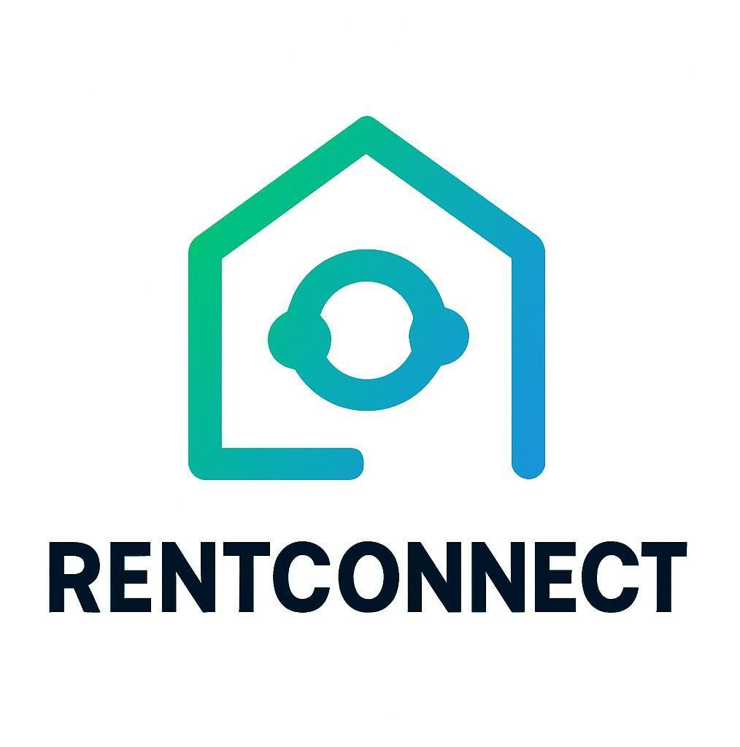
Typography:
A clean sans-serif font was chosen for modernity and readability.

The final logo combines a house icon with a connection symbol, symbolizing digital trust and housing unity. This minimalist yet expressive design was integrated into the website’s header, favicon, and
official documents, ensuring consistent branding across all platforms.

The combination of a meaningful name and a simple, professional logo strengthened RentConnect’s
visual identity, giving the project a distinct and memorable presence.

Implementation Plan / Methodology

The implementation plan defines how the design concepts were transformed into a working system. The project followed a step-by-step implementation methodology to ensure consistent progress and maintain quality throughout.

Phase 1: Environment Setup

    - Installed Visual Studio Code, XAMPP, and Git.

    - Configured local server and created a new MySQL database named “rentconnect_db.”

Phase 2: Frontend Implementation

    - Designed main pages: Home, Property Listings, About, and Contact.

    - Used HTML and Bootstrap for layout, ensuring responsive grids and modern UI.

    - CSS was applied for color schemes, typography, and overall aesthetics.

Phase 3: Backend Implementation

    - Connected PHP files to the MySQL database.

    - Implemented CRUD operations for property management.

    - Added user registration and login features using PHP sessions.

    - Created search filters using SQL queries for dynamic results.

Phase 4: Integration and Testing

    - Linked frontend forms with backend logic.

    - Conducted manual testing of property uploads, searches, and logins.

    - Fixed errors related to validation and session handling.

Phase 5: Deployment

    - Uploaded project files to Hostinger using FTP.

    - Configured the domain and ensured database connectivity on the live server.

    - Performed final tests to verify online accessibility and performance.

The implementation approach followed incremental development, where each module was completed and tested before moving to the next. This ensured minimal rework and a stable final output.
The RentConnect project demonstrates how practical implementation of web technologies can solve real-world challenges. Through disciplined planning, iterative testing, and cloud-based deployment, the system evolved into a dependable, fully functional web application.

CHAPTER 4
RESULTS ANALYSIS AND VALIDATION
The implementation of the RentConnect system marked the transition from theoretical design to a fully operational digital platform. The project successfully achieved its main objective — creating a secure, responsive, and user-friendly real estate web application where property owners, agents, and tenants can interact seamlessly.
The system was deployed on Hostinger, ensuring accessibility through a live web environment. The integration of HTML, CSS, Bootstrap, PHP, and MySQL provided the foundation for dynamic interactions, efficient database handling, and real-time updates.
The implementation process followed a structured plan that included environment setup, frontend and backend development, integration, testing, and deployment. During this stage, specific challenges were addressed — such as ensuring smooth communication between frontend and backend modules, optimizing database queries, and improving UI responsiveness. Each component was implemented with a focus on user experience, scalability, and maintainability.
By the end of the implementation phase, RentConnect was able to provide the following functionalities:
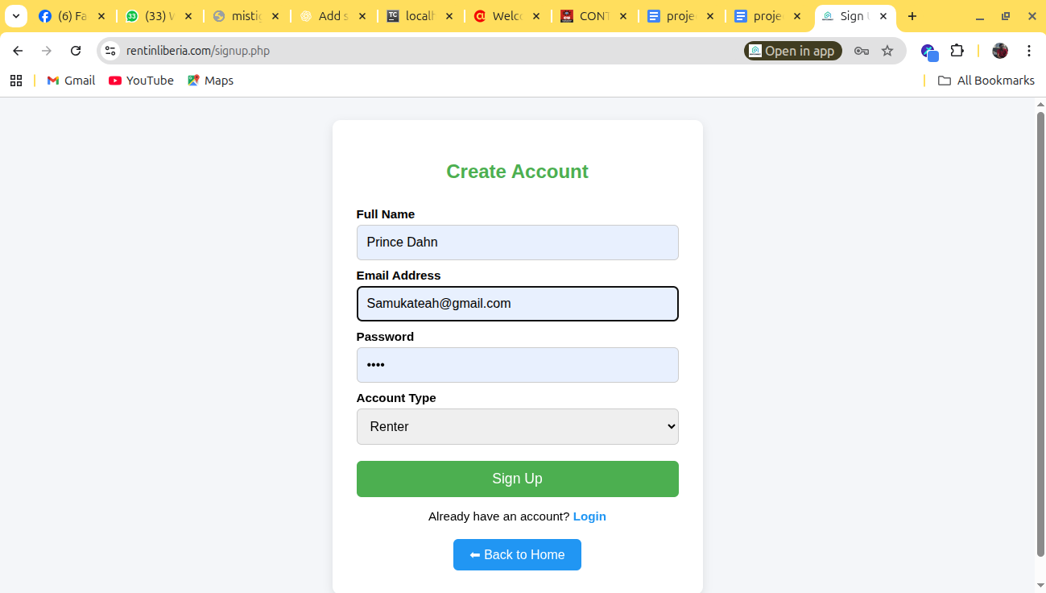
    - User registration and login with encrypted passwords.

    - Property listing management with image upload and description.

    - Property search with filters (location, price range, property type).

    - Contact and inquiry form linking tenants with property owners.

    - Secure database connectivity and reliable session management.

    - Responsive design compatible with desktop, tablet, and mobile devices.
These results demonstrate that RentConnect successfully addressed the problems identified earlier — replacing manual, fragmented rental processes with an efficient, centralized web solution.

Report Preparation
The process of report preparation was an integral and continuous component of the RentConnect project, running concurrently with the phases of system design and development. Maintaining proper documentation was considered essential to ensure that every activity — from initial requirement gathering to final deployment — was clearly recorded, well-structured, and aligned with academic and professional standards. The report not only served as a formal record of work completed but also reflected the developer’s analytical approach, problem-solving techniques, and mastery of software engineering principles.
From the outset, a systematic approach was adopted to ensure that the report preparation process complemented the Software Development Life Cycle (SDLC) methodology followed during the project. Each chapter was designed to capture the logical progression of the system’s development. The report began with an Introduction, which provided context and justification for the project. It then moved into the Background and Literature Review, documenting research on existing real estate
systems and identifying gaps that RentConnect aimed to address. Subsequent chapters covered System Design, Implementation, Results and Analysis, and finally Conclusion and Future Work, offering a comprehensive account of both the technical and conceptual development.
Special attention was given to creating a structured academic framework. Each chapter was divided into numbered sections and subsections to improve readability and flow. For example, the “Design and Process” chapter was broken down into evaluation criteria, design constraints, design flow, and logo creation, ensuring that readers could easily follow the project’s technical narrative. Each section was supported by visual elements such as flowcharts, ER diagrams, use case diagrams, and data flow
diagrams (DFDs). These graphical representations made it easier to visualize system operations and relationships between different components.
As development progressed, the report was continuously updated to reflect new discoveries, code improvements, and design modifications. This iterative documentation approach ensured that the report stayed accurate and aligned with the evolving nature of the project. Every time a major feature — such as the property listing module, search filter, or booking system — was implemented, corresponding updates were made in the report, including explanations of functionality, screenshots of implementation, and database schema modifications. This process provided transparency and made the document a true reflection of the project’s progress.
In addition to technical details, the report emphasized clarity, consistency, and academic presentation. Formatting standards, such as uniform font type and size, consistent headings, and proper alignment,
were maintained throughout. All figures and tables were numbered sequentially and accompanied by descriptive captions to facilitate easy referencing. The language used in the report was kept formal, concise, and free of ambiguity, adhering to academic conventions. Grammatical accuracy and logical coherence were ensured through multiple rounds of proofreading and revision.
The report preparation process also involved careful referencing and citation of sources. Information drawn from books, academic journals, and online documentation (such as W3Schools, MDN, and official PHP or MySQL documentation) was appropriately acknowledged in the References section.
This not only ensured academic integrity but also provided credibility to the theoretical foundations of the work. References were formatted according to recognized citation styles, ensuring consistency and professionalism.
Another crucial element of the report was the inclusion of visual evidence of the system’s functionality. Screenshots of the user interface, admin panels (if applicable), database tables, and PHP code snippets were embedded at appropriate points to support the written explanations. These visuals served as practical proof of implementation and helped bridge the gap between theory and practice. For example, property listing pages, user registration forms, and search result outputs were captured and annotated to illustrate system behavior in real-time scenarios.
The report also highlighted challenges and their corresponding solutions, documenting technical obstacles encountered during development and the methods used to overcome them. This reflective analysis added academic depth by demonstrating critical thinking, adaptability, and problem-solving capabilities. For instance, issues related to database connection errors, cross-browser styling inconsistencies, and hosting configuration were described along with the corrective actions implemented.
Lastly, the preparation of the final report involved ensuring compliance with university submission guidelines. Page numbering, title page design, certificate inclusion, acknowledgments, and declaration statements were formatted according to institutional requirements. The final layout was reviewed for
coherence, accuracy, and readability before submission, resulting in a polished document that accurately represented both the technical work and the academic rigor invested in the project.
In summary, the report preparation process was more than a documentation exercise — it was a
reflection of the development journey, demonstrating how structured reporting contributes to the
success and credibility of a software project. It captured not only the technical aspects of RentConnect but also the analytical reasoning, research foundation, and professional standards that underpin a
complete academic project. Through careful planning, continuous updating, and adherence to academic conventions, the final report emerged as a comprehensive representation of RentConnect’s design, implementation, and impact.

Project Management and Communication
Efficient project management played a vital role in ensuring that RentConnect was completed within the designated timeframe and met all required objectives. The project followed a structured workflow based on the Software Development Life Cycle (SDLC) and elements of Agile methodology, allowing flexibility and iterative improvements.
The development process was divided into weekly milestones — including requirement analysis, design, frontend and backend development, testing, and deployment. Each milestone had clear deliverables and review sessions to monitor progress.
Since this was an individual academic project, communication primarily occurred between the developer (student) and the project supervisor. Regular meetings and feedback sessions ensured alignment with
academic standards and technical expectations. All changes and suggestions were documented and incorporated into subsequent versions of the system.
Version control and collaboration tools such as GitHub were used to manage source code and maintain backups. This ensured version integrity and provided a record of the development history.
Communication was also enhanced through shared documents and progress updates submitted to the supervisor.
The structured project management approach allowed for efficient time utilization, risk mitigation, and clear task prioritization — ensuring that the final system met its intended goals within the eight-week
timeline.
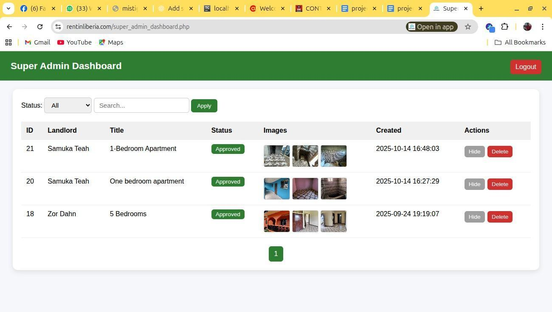

Testing, Characterization, Interpretation, and Data Validation
Testing and validation were crucial stages of the project, aimed at ensuring system reliability, functionality, and accuracy. A comprehensive testing plan was implemented to verify that every module of RentConnect functioned as expected. The testing process consisted of unit testing, integration testing, and user acceptance testing (UAT).

Unit Testing:
Each function and PHP script was tested individually. Examples include validating user registration, verifying database inserts, and checking session variables. The goal was to ensure that each component performed correctly in isolation.

Integration Testing:
After confirming individual components, integration testing examined how they worked together. For example, property search results were tested to ensure that the PHP backend accurately retrieved matching data from the MySQL database and displayed it correctly on the frontend.

User Acceptance Testing (UAT):
A small group of users, including classmates and faculty members, interacted with the system. Their feedback was collected on usability, navigation, and performance. Adjustments were made based on this feedback — such as improving page load speed and simplifying the property upload process.

Data Validation was implemented both at the frontend and backend to prevent errors and maintain data integrity. Input fields were checked for valid entries, while SQL injection prevention techniques and password hashing were applied for security.

Interpretation of Results:
Testing results showed that RentConnect achieved high accuracy and responsiveness in data operations. CRUD functionalities worked efficiently, and search queries delivered relevant results with minimal delay. The system also maintained consistent performance across different devices, proving its responsiveness.
No major system failures occurred during testing, though minor issues like alignment inconsistencies and validation errors were identified and corrected. Overall, RentConnect passed all major tests and was validated as a reliable and functional platform for online property rental management.

Summary of Results
The implementation and validation phases demonstrated that the RentConnect platform effectively met its objectives. It delivered a real-world solution that streamlined property management, enhanced accessibility, and promoted trust among users. The combination of robust backend logic, responsive design, and reliable deployment created a complete, professional-grade web application.
In conclusion, Chapter 4 confirms the technical and functional success of the RentConnect system. The testing outcomes, performance metrics, and validation processes all indicate that the project not only
fulfills its initial goals but also stands as a scalable foundation for future enhancements such as integrated payments, mobile applications, and AI-driven property recommendation

CHAPTER 5 CONCLUSION AND FUTURE WORK

Conclusion

The RentConnect project represents a successful integration of modern web development and cloud deployment techniques to address real-world challenges in the real estate rental sector. The system was designed to simplify, digitalize, and enhance the process of renting and managing properties through a centralized, secure, and interactive online platform.
Throughout the development of RentConnect, the primary focus remained on creating a user-friendly experience while ensuring efficiency, scalability, and reliability. The project achieved this by using widely adopted web technologies — HTML, CSS, Bootstrap, PHP, and MySQL — each contributing to a responsive, functional, and easily maintainable system. The deployment of the system on Hostinger made it accessible to users through a live, cloud-based environment, ensuring that landlords, tenants, and agents could connect seamlessly from anywhere.
The project effectively met its core objectives:

    - It provided a reliable space for property owners to list and manage their rental properties.

    - It enabled tenants to search for properties using filters such as price, location, and property type.

    - It allowed users to communicate easily through the contact and booking forms.

    - It ensured security through input validation, password encryption, and controlled access.

Beyond technical achievement, RentConnect also demonstrated a deep understanding of real-world user behavior. Traditional property management methods are often time-consuming, manual, and fragmented
— leading to inefficiencies and miscommunication. By creating an online alternative that automates these processes, RentConnect not only enhances convenience but also contributes to transparency and trust within the rental ecosystem.
The development process also served as a valuable learning experience in the application of Software Development Life Cycle (SDLC) principles, database management, and DevOps practices. From requirement gathering to deployment, each phase offered insights into how theoretical knowledge can be
practically applied to solve real-world problems. The inclusion of continuous testing, debugging, and code reviews strengthened the reliability of the platform and improved problem-solving skills.
Moreover, RentConnect demonstrated the importance of design thinking — prioritizing user experience, clarity, and simplicity. Through consistent evaluation and testing, the system evolved into an accessible platform that can easily be extended to include more advanced functionalities in the future.
In summary, RentConnect fulfills its purpose as a scalable, secure, and user-oriented web solution that brings innovation to property management. It stands as evidence of how technology can be harnessed to bridge communication gaps, automate processes, and empower users through accessibility and transparency.

Limitations

Despite the successful implementation and deployment, a few limitations were observed:

Absence of Real-Time Features:
The current version lacks live chat or real-time messaging capabilities. This limits instant communication between tenants and landlords.

No Online Payment Integration:
RentConnect does not yet include online payment gateways for rental transactions. This feature is crucial for a complete digital rental system.

Limited Administrative Control:
The platform does not include an admin dashboard for monitoring users, managing listings, or tracking analytics.

Scalability Constraints:
As the platform is hosted on a shared hosting plan, high traffic may affect performance in the long term. Migration to a cloud service like AWS or Azure could resolve this.

Basic Security Implementation:
While password encryption and form validation were included, advanced security mechanisms like multi-factor authentication and encryption of sensitive user data were not implemented due
to time constraints.

These limitations do not undermine the project’s overall success but highlight opportunities for improvement in future versions.

Future Enhancements

Technology evolves rapidly, and web-based systems must adapt to remain effective. The following enhancements are proposed to improve the scalability, usability, and competitiveness of RentConnect:

Integration of Online Payment Gateway:
Implementing secure payment gateways such as PayPal or Stripe would allow users to complete rental payments directly through the platform. This would provide a complete end-to-end solution for property management.

Mobile Application Development:
Building a dedicated Android and iOS app using technologies like Flutter or React Native would make RentConnect more accessible, particularly for users who prefer mobile browsing.

Real-Time Chat and Notification System:
Incorporating technologies such as Firebase or WebSockets could enable instant communication and live notifications for booking confirmations or inquiries.

Advanced Search and Recommendation System:
Implementing AI-based recommendation algorithms could personalize the search experience, suggesting properties based on user preferences and search history.

Admin Dashboard and Analytics:
Adding an admin panel with analytics tools would help track user engagement, property listings, and system performance. This feature would also enhance security and content management.

Enhanced Security Features:
Future versions could include advanced security layers such as two-factor authentication, HTTPS enforcement, and data encryption for user information.

Cloud Scalability:
Migrating the system to cloud platforms like AWS, Google Cloud, or Azure would provide greater scalability, automated backups, and improved performance for handling large-scale data.

Each of these enhancements would expand RentConnect’s functionality, making it more competitive with commercial real estate systems while maintaining its focus on simplicity and accessibility.

Final Thoughts

The journey of developing RentConnect was both technically enriching and personally fulfilling. It not only strengthened programming and project management skills but also fostered critical thinking, creativity, and resilience. The project successfully translated theoretical knowledge into a tangible system that solves a genuine problem in the real estate domain.
By combining modern technologies, practical design, and user-focused development, RentConnect sets the foundation for future innovation in property rental management. It reflects the vision of digital transformation a move toward smarter, faster, and more transparent solutions for everyday challenges.
Ultimately, RentConnect stands as more than just an academic project; it represents a blueprint for scalable and socially impactful technological solutions. With future improvements and continuous innovation, the platform has the potential to become a complete digital hub for real estate rental services
— connecting people, simplifying lives, and contributing meaningfully to the digital economy.

REFERENCES

Welling, L., & Thomson, L. (2017). PHP and MySQL Web Development (5th ed.). Addison-Wesley Professional.
Duckett, J. (2011). HTML and CSS: Design and Build Websites. Wiley Publishing. Flanagan, D. (2020). JavaScript: The Definitive Guide (7th ed.). O’Reilly Media. Beighley, L., & Morrison, M. (2017). Head First PHP & MySQL. O’Reilly Media. MySQL Documentation. (2024). MySQL 8.0 Reference Manual. Oracle Corporation. Retrieved from https://dev.mysql.com/doc/
Mozilla Developer Network (MDN). (2024). HTML, CSS, and JavaScript Tutorials.
Retrieved from https://developer.mozilla.org/
W3Schools. (2024). PHP Tutorial. Retrieved from https://www.w3schools.com/php/ GitHub Docs. (2024). Deploying Websites with GitHub Pages and Actions. Retrieved from https://docs.github.com/
Hostinger Tutorials. (2024). How to Deploy a PHP Website on a Web Server. Retrieved from https://www.hostinger.com/tutorials/
IEEE Xplore Digital Library. (2019–2024). Research Papers on Cloud-Based Property Management and Web System Automation. Retrieved from https://ieeexplore.ieee.org/ SpringerLink Journals. (2020–2024). Studies on Digital Transformation in Real Estate and DevOps in Web Development. Retrieved from https://link.springer.com/ GeeksforGeeks. (2024). PHP and MySQL Connection Guide. Retrieved from
https://www.geeksforgeeks.org/
Bootstrap Documentation. (2024). Bootstrap 5 Official Guide. Retrieved from https://getbootstrap.com/docs/5.0/

Hostinger Blog. (2023). Top Security Practices for Hosting PHP Websites. Retrieved from https://www.hostinger.com/blog/
FreeCodeCamp. (2023). Responsive Web Design Principles. Retrieved from https://www.freecodecamp.org

